AUTHENTICATION OF APPLIANCE:
- Appliance Signature Analysis:
  - Each electrical appliance has a unique power consumption signature (load profile).
  - Implement algorithms to learn and recognize the power signatures of authenticated appliances in a home.
  - This can be achieved through machine learning techniques that analyze variations in voltage, current, and frequency corresponding to different appliance operations.
- Smart Meter Data Utilization:
  - Smart meters can record fine-grained electricity usage data.
  - Use this data to identify the operational patterns of authenticated appliances.
  - Detect anomalies when there is a deviation from the usual patterns, which could indicate unauthorized usage or tampering.
- Integration with Home Automation Systems:
  - Integrate the ETD model with home automation systems that have information about registered appliances.
  - Use this integration to cross-reference power usage data with the list of authenticated appliances.
  - Anomalies can be flagged when power consumption does not match the expected usage from registered appliances.
- Real-Time Monitoring and Authentication Checks:
  - Implement real-time monitoring of electricity consumption.
  - Perform authentication checks periodically to ensure that the power usage corresponds to registered appliances.
  - Any unauthorized appliance usage or sudden changes in consumption patterns can trigger alerts.
- Machine Learning for Anomaly Detection:
  - Utilize supervised and unsupervised machine learning algorithms to detect unusual patterns that do not conform to the recognized appliance usage profiles.
  - Train the model with datasets that include normal operations and various theft scenarios.
- User Interaction and Feedback:
  - Allow users to provide feedback on alerts generated by the ETD system.
  - Users can confirm whether a flagged anomaly is indeed a theft or a legitimate change in usage, helping to refine the model's accuracy.
- Security and Privacy Considerations:
  - Ensure that data collection and processing comply with privacy regulations.
  - Implement secure communication protocols to protect data transmitted between smart meters, appliances, and the ETD system.
By integrating appliance authentication into your ETD model, you can create a more robust and accurate system for detecting electricity theft. This approach can effectively discern between normal usage patterns and potential theft scenarios, thereby enhancing the overall security of electricity usage monitoring.
Methodology
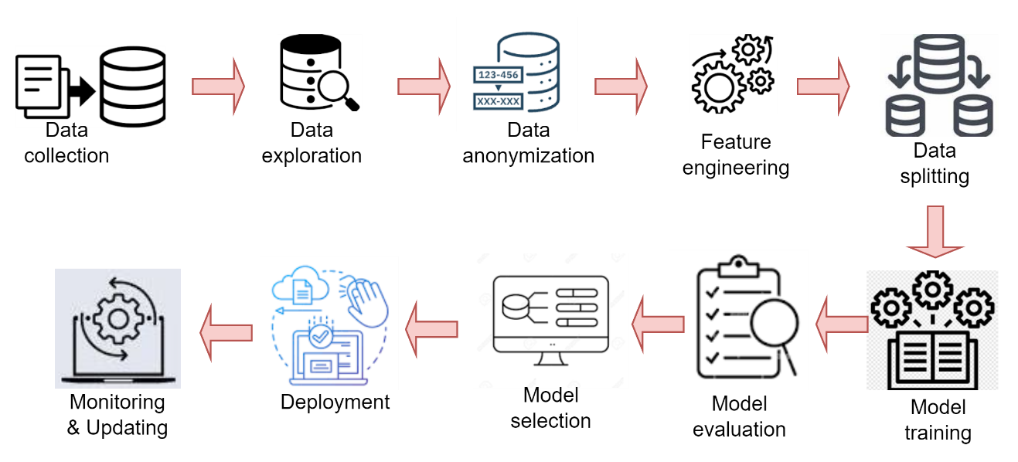
Proposed methodology flow chart
Features of our datasets
I will now read the contents of the file Electricity_B1E.csv to understand its structure and the nature of the data it contains. Let's proceed with this analysis.
The contents of the Electricity_B1E.csv file reveal the following structure:
- unix_ts: UNIX timestamp, representing the time of the reading.
- V: Voltage (in volts).
- I: Current (in amperes).
- f: Frequency (in hertz).
- DPF: Displacement Power Factor.
- APF: Apparent Power Factor.
- P: Active Power (possibly in watts).
- Pt: Total Active Power (cumulative, possibly in watt-hours).
- Q: Reactive Power (possibly in vars).
- Qt: Total Reactive Power (cumulative, possibly in var-hours).
- S: Apparent Power (possibly in volt-amperes).
- St: Total Apparent Power (cumulative, possibly in volt-ampere hours).
Given this structure, the power_base dataset in the script would have the following features:
- Time Components:
  - Day: The day number relative to the baseline (day_offset).
  - Minute: The minute of the day.
- Aggregated Power Readings:
  - Since the script specifically extracts the active power (P) for its processing (as seen in power=float(row[6])), the aggregated data in power_base would consist of the sum of active power readings from selected meters (base_names) for each minute of each day.
Therefore, each entry in power_base represents the total active power consumption (in watts or a similar unit) from a subset of meters, for each minute of each day over a period of 730 days. This aggregated dataset forms a baseline for normal power consumption patterns against which deviations (such as potential electricity theft) can be compared. ​

Overview of appliance data sample. E.g OUE -outside plug
- unix_ts: Unix timestamp, indicating the time at which the data was recorded.
- V: Voltage measurement.
- I: Current measurement.
- f: Frequency.
- DPF: Displacement Power Factor.
- APF: Apparent Power Factor.
- P: Power.
- Pt: Cumulative Power over time.
- Q: Reactive Power.
- Qt: Cumulative Reactive Power over time.
- S: Apparent Power.
- St: Cumulative Apparent Power over time.
Regarding data anonymity, this dataset does not contain any direct personal identifiers like names, addresses, or specific geographic locations. However, there are a few considerations for assessing its anonymity:
- Temporal Data: The Unix timestamp (unix_ts) provides specific time points for data collection. In certain contexts, time data can be sensitive, especially if it could be correlated with known events or schedules of individuals.
- Aggregated or Individual Data: This dataset appears to be a collection of individual readings (every minute, as suggested by the Unix timestamps). If these readings are tied to specific households or locations, there might be a risk of identifying individuals indirectly, especially if combined with other data.
- Lack of Personal Identifiers: The absence of explicit personal identifiers like names or IDs is a positive aspect in terms of anonymity.

unix_ts V I f DPF APF P Pt Q Qt S St
0 1333263600 118.8 0.0 60.0 1.0 1.0 0 271 0 31 0 298
1 1333263660 119.3 0.0 60.0 1.0 1.0 0 271 0 31 0 298
2 1333263720 119.0 0.0 60.0 1.0 1.0 0 271 0 31 0 298
3 1333263780 119.1 0.0 60.0 1.0 1.0 0 271 0 31 0 298
4 1333263840 118.8 0.0 60.0 1.0 1.0 0 271 0 31 0 298

To determine the best feature for measuring appliance consumption patterns, we consider how each feature relates to energy consumption and how well it might differentiate between different consumption patterns. Let's review each feature:
- unix_ts (Unix timestamp): This is a time reference and doesn't directly relate to energy consumption. It's useful for time series analysis but not as a measure of consumption.
- V (Voltage): While voltage levels can impact power consumption, in most residential and commercial settings, voltage is relatively constant. It's not a direct measure of consumption but can be relevant in some analyses.
- I (Current): Current is directly related to power consumption (P = VI, where V is voltage and I is current). Fluctuations in current can indicate changes in appliance consumption patterns.
- f (Frequency): In most power systems, the frequency is quite stable. Variations are usually an indication of grid instability rather than appliance consumption patterns.
- DPF (Displacement Power Factor): This measures the efficiency of power usage but doesn't directly indicate consumption levels. It's more about the quality of consumption than the quantity.
- APF (Apparent Power Factor): Similar to DPF, it indicates the efficiency of power usage and is more about power quality.
- P (Power): Power is a direct measure of energy consumption at any given moment. It's one of the most direct measures of appliance consumption.
- Pt (Total Power): If this is cumulative power over time, it's an excellent measure of total consumption but less useful for instantaneous consumption patterns.
- Q (Reactive Power): This is related to the energy stored in the load and returned to the source and is more about the type of load than the quantity of consumption.
- Qt (Total Reactive Power): Similar to Q, but cumulative. It's more relevant in assessing load type over time rather than consumption patterns.
- S (Apparent Power): It's a combination of reactive power and real power and gives a total power figure but doesn't directly measure consumption efficiency.
- St (Total Apparent Power): The cumulative apparent power over time. Like S, it encompasses both active and reactive power but doesn't directly indicate consumption patterns.
- label (Categorical Target Variable): This is the target for classification and not a feature to measure consumption.
Conclusion: Based on this analysis, P (Power) and I (Current) are likely the best features for measuring appliance consumption patterns, as they directly reflect the amount of electric power being used at any given moment. Pt (Total Power) could be useful for understanding longer-term consumption patterns. The choice between these depends on whether you're interested in instantaneous power usage (P, I) or cumulative usage over time (Pt).

PRIVACY CONCERNS:
Developing a model to protect smart home users' privacy using an appliance consumption patterns dataset involves several steps. The primary goal is to ensure that the model can analyze or predict patterns without exposing sensitive personal information. Here's a general outline of how you might approach this:
1. Understanding the Dataset
- Data Inspection: Understand what data you have, including types of appliances, usage patterns, timestamps, and any user-identifiable information.
- Privacy Concerns Identification: Identify which data elements might pose privacy risks (like usage patterns that can infer when someone is home).
2. Data Anonymization
- Anonymizing Data: Apply techniques like pseudonymization (replacing private identifiers with fake identifiers) or aggregation (summarizing data in a way that individual details are not discernible).
- Noise Addition: Introduce some randomness into the data to further obscure individual patterns.
3. Differential Privacy (Optional)
- Implement differential privacy techniques if you're dealing with highly sensitive data. Differential privacy ensures that the removal or addition of a single dataset does not significantly affect the outcome, thereby protecting individual privacy.
4. Feature Engineering
- Select Relevant Features: Choose features relevant to the analysis but less likely to compromise privacy.
- Create Derived Features: Sometimes, derived features can provide useful insights without revealing sensitive information.
5. Model Development
- Choose a Model: Depending on your objective (e.g., predicting energy usage, identifying abnormal consumption patterns), select an appropriate machine learning model.
- Train the Model: Use the anonymized and engineered dataset to train your model.
6. Model Validation and Testing
- Cross-Validation: Use techniques like k-fold cross-validation to validate your model.
- Performance Metrics: Evaluate the model using appropriate metrics (accuracy, F1-score, etc.), ensuring the privacy-preserving measures don't overly degrade performance.
7. Deployment and Monitoring
- Deploy the Model: Integrate the model into the smart home system.
- Monitor and Update: Continuously monitor the model's performance and update it as needed to adapt to new patterns or privacy concerns.
8. Compliance and Ethical Considerations
- Ensure that your model and data handling practices comply with relevant data protection laws (like GDPR, CCPA).
- Regularly review ethical considerations, especially regarding how data is used and the implications of your model's predictions or insights.
Tools and Technologies
- Programming Languages: Python, R (for data analysis and model development).
- Libraries: Pandas, NumPy (for data manipulation), Scikit-learn, TensorFlow, or PyTorch (for machine learning).
- Differential Privacy Libraries: TensorFlow Privacy, PySyft, or Opacus.
Security Measures
- Secure data storage and transmission.
- Regular audits for data and model security.
Developing such a model requires a balance between utility and privacy. It's crucial to maintain this balance to ensure the model is effective without compromising user privacy.
Next Steps:
- Data Anonymization:
  - The dataset is already anonymized as it contains numerical readings without any direct personal identifiers.
  - If there are columns with potentially identifiable information (not visible in the first few rows), we should anonymize or remove them.
- Feature Engineering and Anomaly Detection:
  - Identify which features are most relevant for detecting abnormal consumption patterns.
  - Create new features, if necessary, for example, aggregating readings to represent total consumption over certain periods.
- Train Models:
  - Split the smaller training dataset into training and validation sets.
  - Train the XGBoost, Random Forest, and MLP models on these sets.
- Model Evaluation:
  - Evaluate the models using the test dataset (psa_journal_home_A_sim_test.csv).
  - Compute performance metrics such as Accuracy, Recall, Precision, F1-Score, and AUC.
To visualize the anonymized dataset in a way that demonstrates its privacy, we can create visualizations that show aggregated or generalized patterns without revealing any specific details that could be linked to individual homes or users. Since the dataset is already in an anonymized form with numerical readings and no direct personal identifiers, we can create visualizations that focus on general trends or distributions.
Here are a few visualization ideas:
- Histograms of Feature Distributions: Show the distribution of readings across different features to understand the range and common values.
- Heatmaps of Correlation: Display the correlation between different features to see if any interesting patterns emerge.
- Time Series Plots: If the features represent time-series data, plot them to show general consumption trends over time.
- Box Plots for Anomaly Visualization: Box plots can help identify outliers or anomalies in the data, which is useful for understanding abnormal consumption patterns.
Let's start with histograms and a heatmap of correlations. We'll select a subset of features for these visualizations to keep them interpretable.

Visualizations of the Anonymized Dataset
- Histograms of Selected Features:
  - These histograms show the distribution of values for the first 20 features in the dataset.
  - The histograms provide a sense of the data spread and common value ranges without revealing any specific user details.
  - This level of aggregation ensures privacy as individual data points are not distinguishable.
- Correlation Heatmap:
  - The heatmap illustrates the correlation between the selected features.
  - It helps in understanding the relationships between different measurements without pinpointing any specific individual or event.
  - The lack of identifiable information in the correlation matrix further ensures the privacy of the dataset.
These visualizations demonstrate how data can be presented in a way that provides insights while maintaining user privacy. The absence of any direct or indirect identifiers, such as names, addresses, or specific timestamps, helps in preserving the anonymity of the data.
If you have any specific aspects of the dataset or different types of visualizations in mind that you'd like to explore, please let me know. Otherwise, we can proceed to the feature engineering and model training phase

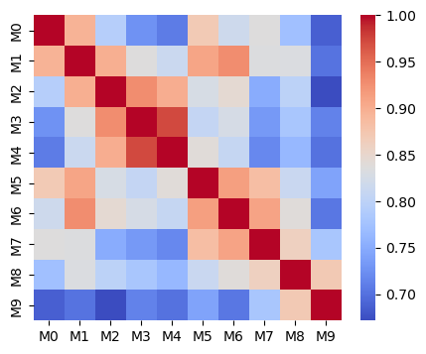
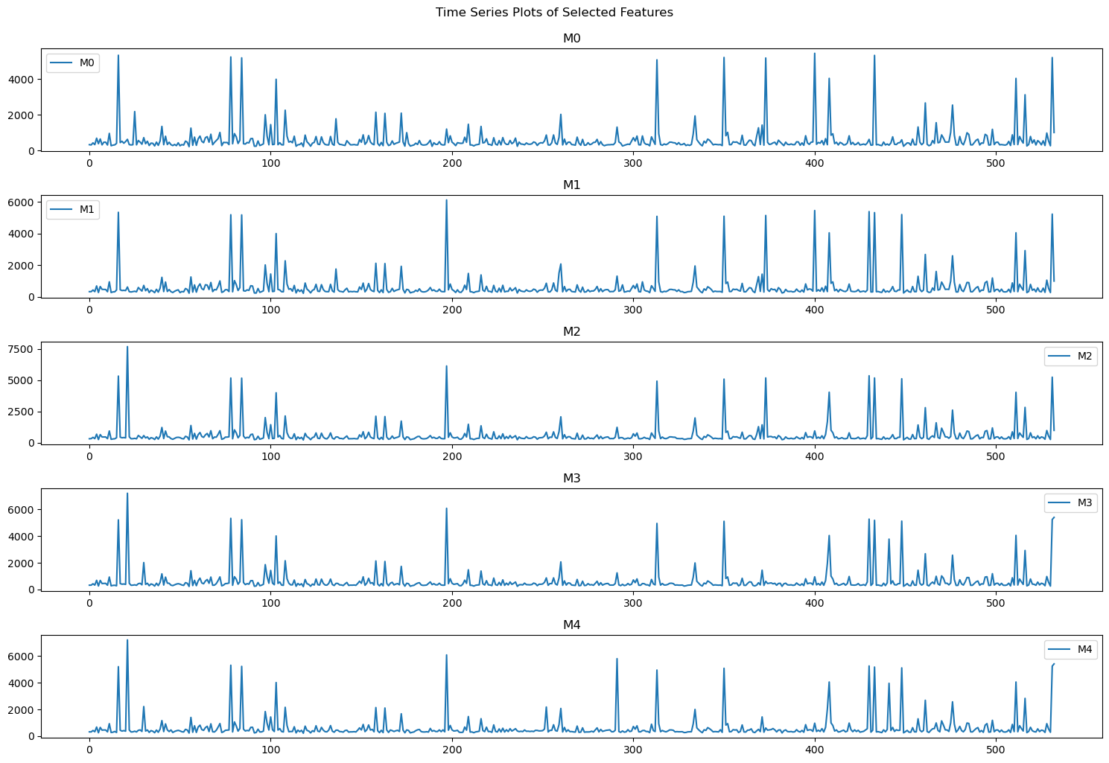
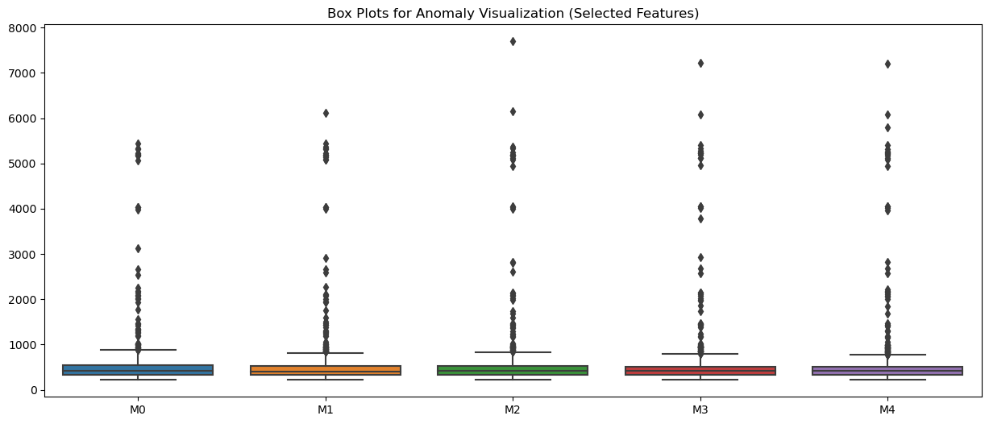

HARMONIC AND ARITHMETIC MEAN FOR ANOMALY DETECTION
The harmonic mean and arithmetic mean are two different ways to calculate the average of a set of numbers. To generate a mathematical equation that combines these two means for the purpose of anomaly detection in electricity theft, we first need to define the means:
- Arithmetic Mean (AM): The arithmetic mean of a set of �n numbers �1,�2,…,��x1​,x2​,…,xn​ is calculated as: ��=1�∑�=1���AM=n1​∑i=1n​xi​
- Harmonic Mean (HM): The harmonic mean of the same set of numbers is calculated as: ��=�∑�=1�1��HM=∑i=1n​xi​1​n​
Now, to combine these for anomaly detection, we can consider the ratio of the harmonic mean to the arithmetic mean. This ratio is a dimensionless number and can be useful in identifying outliers or anomalies in data, such as unusually high or low electricity consumption that could indicate theft. The equation for this ratio, which I'll call the Harmonic-Arithmetic Mean Ratio (HAMR), is:
����=����=�/∑�=1�1��1�∑�=1���HAMR=AMHM​=n1​∑i=1n​xi​n/∑i=1n​xi​1​​
In the context of electricity theft detection, you would calculate HAMR for a set of power consumption readings. Anomalies might be indicated by HAMR values that deviate significantly from the norm. For example, a very low HAMR might indicate periods of unusually high consumption (potential theft), whereas a high HAMR could indicate periods of unusually low consumption. The specific threshold for what constitutes an anomaly would depend on the context and the typical range of HAMR values in normal conditions.

DISCUSS THE DIFFERENCE BETWEEN PREVENTION AND CONSUMPTION OF THE SYSTEM
In the context of electricity theft detection in a smart home, "consumption" and "prevention" have specific meanings related to the management and safeguarding of electrical resources:
- Consumption: This refers to the usage of electricity by various devices and systems within the smart home. Consumption patterns can be monitored and analyzed for various purposes, including efficiency optimization, cost calculation, and detecting anomalies. Smart meters and home energy management systems can track which devices are using electricity, how much they are using, and at what times. This data is crucial for understanding normal electricity usage patterns in the home.
- Prevention (in the context of electricity theft): This involves measures and strategies to prevent unauthorized use or theft of electricity. Electricity theft can occur in various ways, such as physically tampering with meters, bypassing meters, or hacking into smart metering systems. Prevention strategies include:
  - Technical Measures: These could be improved security features in smart meters, such as tamper detection sensors, encryption of data transmission, or secure authentication protocols.
  - Data Analysis and Anomaly Detection: By analyzing consumption data, unusual patterns that might indicate theft can be detected. For example, a significant unexplained increase in consumption or patterns that don't match the expected usage profile of the household might trigger an investigation.
  - Regular Inspections and Audits: Physical inspections of meters and wiring can help detect tampering or bypass attempts.
Consumption Pilot Approach
In this context, the relationship between consumption and prevention is critical. Analyzing electricity consumption data not only helps in managing and optimizing energy use but also plays a vital role in the prevention of electricity theft. By understanding normal consumption patterns, anomalies that might suggest theft can be more easily identified and investigated.
The term "consumption pilot approach" in the context of electricity usage, particularly in smart homes or smart grids, typically refers to a pilot study or a trial program aimed at understanding, monitoring, and optimizing electricity consumption. This kind of approach is often used to test new technologies, methodologies, or behavioral interventions before a broader rollout. Let's break down what this might involve:
Objectives of a Consumption Pilot Approach
- Testing Smart Technologies: Implementing smart meters, smart appliances, and energy management systems to collect detailed data on electricity usage.
- Analyzing Consumption Patterns: Understanding how, when, and where electricity is used in a household or community. This can include peak usage times, the most energy-intensive appliances, and typical usage behaviors.
- Identifying Opportunities for Efficiency: Looking for ways to reduce energy waste, such as through automated systems that turn off appliances when they're not in use, or optimizing heating and cooling schedules.
- Encouraging Behavioral Change: Informing residents about their consumption patterns and encouraging energy-saving behaviors.
- Testing Demand Response Programs: Assessing how consumers might adjust their usage in response to real-time information about electricity prices or grid demand.
Components of a Consumption Pilot Approach
- Technology Implementation: Installation of smart meters and other IoT devices for real-time monitoring and control.
- Data Collection and Analysis: Gathering and analyzing consumption data to understand usage trends and anomalies.
- User Participation: Involving the end-users (residents) in the pilot, both as sources of data and as active participants in energy-saving strategies.
- Feedback Mechanisms: Providing feedback to users about their consumption, often through apps or online dashboards.
- Evaluation of Results: Assessing the effectiveness of different strategies or technologies in reducing consumption or shifting load patterns.
Potential Outcomes
- Energy Savings: Reduction in overall energy use and cost savings for consumers.
- Improved Grid Management: Better load balancing and reduced peak demand stress on the grid.
- Behavioral Insights: Understanding how consumers interact with smart technology and respond to energy-saving initiatives.
- Policy and Strategy Development: Informing broader energy policies or strategies for scaling up successful interventions.
A consumption pilot approach is particularly valuable in the context of smart grids and sustainable energy management. It allows for testing and refining approaches in a controlled but real-world setting before applying them more widely.

Electricity Theft Attacks in Smart Homes
Electricity theft in smart homes, particularly through manipulation of appliance consumption patterns, can be executed in several ways. These theft methods exploit the smart home's electrical system or the data communication network of smart meters and appliances. Here are various types of electricity theft attacks:
- Meter Tampering: Physically manipulating the smart meter so it under-reports consumption. This can involve tampering with the meter's hardware to slow down or alter its recording of electricity usage.
- Bypassing the Meter: Illegally connecting electrical lines before the meter or bypassing the meter entirely. This allows electricity to be used without being measured by the meter.
- Remote Hacking: Gaining unauthorized access to the smart meter's software or firmware through hacking. This can be used to alter the reported consumption data or to interfere with the meter's normal operation.
- Data Fabrication/Injection: Injecting false data into the system to under-report actual consumption. This can be done by manipulating the data transmitted from the smart meter to the utility provider.
- Appliance Misreporting: Hacking into smart appliances to report lower consumption than is actually occurring. Since many smart homes rely on the Internet of Things (IoT) devices, these appliances can be targets for hackers to alter reported energy use.
- Energy Resale or Redistribution: Illegally siphoning off electricity to sell to others or redistributing to different locations. This involves using one connection to supply multiple users, with only one user (or none) being billed.
- Cloning Smart Meters: Copying the identity of a legitimate smart meter and using it for another connection. This allows a user to consume electricity under another user's account.
- Signal Jamming or Interference: Using devices to jam or interfere with the communication signals of smart meters. This can disrupt the transmission of accurate consumption data to the utility company.
- Algorithmic Predictive Manipulation: Sophisticated theft methods could involve using machine learning or algorithmic techniques to predict when audits or inspections are likely to happen and temporarily reduce theft activities to avoid detection.
- Power Reselling/Redistribution Via Smart Inverters: In homes with renewable energy systems like solar panels, smart inverters can be manipulated to disguise stolen grid power as self-generated power.
These methods represent a mix of old-fashioned physical tampering and modern digital hacking, reflecting the challenges posed by the digital transformation of energy systems. Utilities and smart home providers are continuously working to strengthen security measures to prevent such thefts. This includes improved physical security for meters, advanced encryption for data transmissions, regular firmware updates, and anomaly detection algorithms to identify unusual consumption patterns indicative of theft.
Where does ETD resides within the smart home:
Electricity Theft Detection (ETD) models in a smart home environment can be implemented and reside in various locations within the home's network and energy management system. These models monitor anomalies in consumption patterns of appliances and detect external attacks. Here are the primary locations where ETD models can be situated:
- Smart Meters: Many modern smart meters have the capability to run basic ETD models. These meters continuously monitor electricity consumption and can detect anomalies in usage patterns that may indicate theft. They can flag unusual changes in consumption that don't align with the homeowner's typical usage profile.
- Home Energy Management Systems (HEMS): A HEMS centralizes the control and monitoring of home energy use, including electricity consumption by appliances. Advanced HEMS can integrate ETD models that analyze consumption data in real-time, looking for patterns indicative of theft or tampering.
- Edge Devices/Gateways: In a smart home, edge devices or gateways act as a bridge between the home network and external networks. ETD models deployed here can process data locally, reducing latency and reliance on cloud services. This local processing can quickly identify anomalies and potential security breaches.
- Cloud-Based Analytics: In many smart home setups, consumption data is sent to cloud-based services for more comprehensive analysis. ETD models in the cloud can use powerful algorithms and machine learning to analyze data from multiple homes, gaining insights that might not be apparent from a single home's data alone.
- Network Routers and Firewalls: These network devices can host security-focused ETD models that monitor for signs of external cyber attacks, such as hacking attempts on the smart meter or unauthorized access to the home network.
- Distributed Energy Resources (DER) Management Systems: In homes equipped with DERs (like solar panels or battery storage), the management systems for these resources can include ETD models to ensure that the reported production and storage of energy align with actual usage.
- Appliance-Level Monitors: Some smart appliances or additional monitoring devices can track their own energy use. ETD models at this level can detect discrepancies in reported usage that might indicate tampering or malfunction.
- Utility Provider Systems: While not located within the home, utility providers often have sophisticated ETD systems that analyze consumption data from multiple homes. They look for patterns that might indicate systemic issues, including theft.
In practice, a combination of these locations is often used for a more robust and layered approach to theft detection. Each layer adds a level of security and data analysis, improving the overall effectiveness of the ETD system. Additionally, the integration of IoT and AI technologies in smart homes is increasingly enabling more sophisticated and proactive ETD models that can adapt to changing patterns and emerging threats.
How does our Model Updates New devices?
In the context of a smart home system or an Electricity Theft Detection (ETD) model, updating the model to accommodate new devices involves several key steps and considerations. These are crucial to ensure that the model remains effective and accurate as new appliances or devices are added to the home network. Here's how the process typically works:
- Device Registration and Integration:
  - When a new device is added to the smart home system, it must first be registered. This includes recognizing the device type, its energy consumption patterns, and other relevant characteristics.
  - The device is integrated into the home's network, allowing it to communicate with the central energy management system or the smart meter.
- Data Collection and Analysis:
  - The system begins collecting data from the new device, including its energy usage patterns.
  - Initial data may be compared to known patterns for similar devices to establish a baseline for normal behavior.
- Model Retraining or Updating:
  - With the accumulation of sufficient data, the ETD model may undergo retraining to incorporate this new information. This can be done through techniques like machine learning, where the model adjusts to new patterns of energy usage.
  - In some systems, this retraining process can be automated, especially if the model is based in the cloud or on a platform that supports continuous learning.
- Anomaly Detection Adjustment:
  - The model's parameters for anomaly detection are adjusted to account for the normal operating range of the new device. This helps in avoiding false positives where the normal operation of the new device might be mistakenly flagged as an anomaly or theft.
- Continuous Monitoring and Learning:
  - The system continuously monitors the new device, refining its understanding of normal usage patterns over time.
  - If the system is AI-driven, it may continually learn and adapt to subtle changes in the device's behavior.
- Feedback Loop:
  - Feedback from the homeowners or system administrators can be used to further refine the model. For instance, if a new device is flagged incorrectly as an anomaly, this feedback can be used to adjust the model.
- Security Measures:
  - New devices can introduce vulnerabilities. The system needs to ensure that adding a new device doesn't compromise overall security. This might involve updating firewalls or security protocols.
- Utility and Manufacturer Updates:
  - Sometimes, updates from the device manufacturer or the utility provider can also inform how the model should be updated. These updates might include information on typical consumption patterns or known issues with a particular device.
In summary, updating an ETD model or a smart home system to accommodate new devices involves a combination of integrating the device into the system, collecting and analyzing data from the device, adjusting the model to understand the device's normal usage patterns, and ensuring ongoing monitoring and security. This process is essential to maintain the accuracy and effectiveness of the system in detecting electricity theft and managing energy consumption.
Proposed System Model for ETD
The ETD model in the figure is broken down into sequential stages, each detailed as follows:

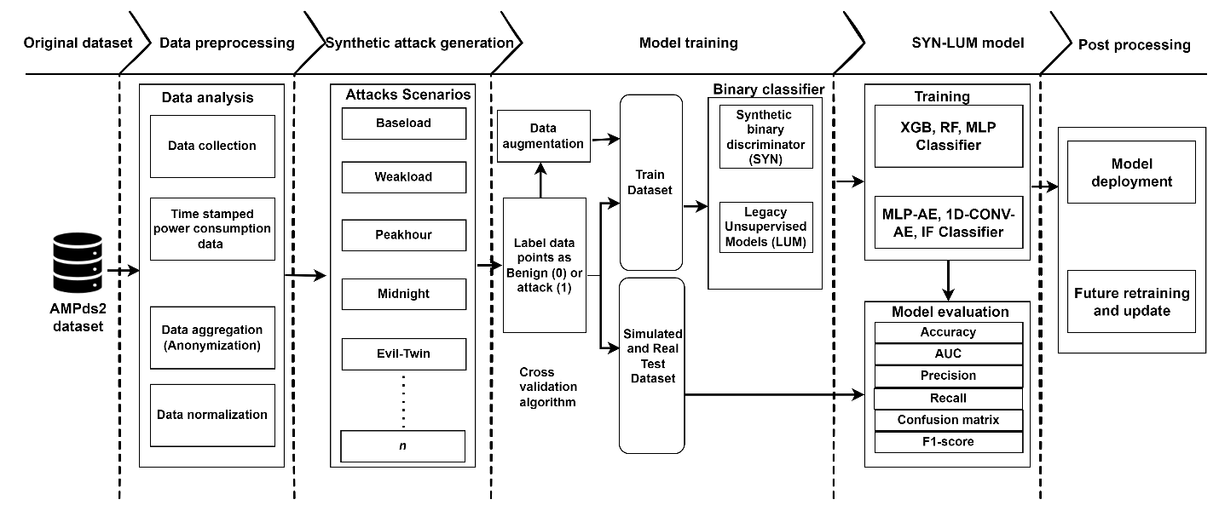
- Data Collection: This stage involves gathering detailed electricity usage data recorded over time from appliances within a smart home.
- Data Processing:
  - Data Aggregation: Data from various appliances is combined to create a comprehensive view of a home's power usage, with measures to protect user privacy.
  - Data Normalization: Variations in scale across different devices are standardized to create a consistent dataset for analysis.
- Attack Simulation: Simulates various theft scenarios, like consistent overuse (Baseload), occasional high usage (Peakhour), and covert theft patterns (Evil-Twin), to train the system to recognize theft patterns.
- Data Augmentation: Techniques are applied to expand the dataset, creating more examples for the model to learn from, such as slight variations in the attack patterns.
- Labeling: Each data point is categorized as either normal consumption (0) or indicative of theft (1).
- Training Dataset: This labeled dataset is used to train the detection algorithms to differentiate between normal and anomalous usage.
- Testing Dataset: Contains both simulated data and real-world data, used to test and validate the accuracy of the trained models.
- Model Types:
  - Synthetic Binary Discriminator (SYN): A specialized model designed to distinguish between two classes: normal and theft.
  - Legacy Unsupervised Models (LUM): Previous models that learn to detect anomalies without labeled training data.
- Classifiers: Refers to the algorithms used, such as XGBoost (XGB), Random Forest (RF), Multi-Layer Perceptron (MLP), autoencoders (AE), and one-dimensional convolutional autoencoders (1D-CONV-AE), along with anomaly detection classifiers like Isolation Forest (IF).
- Evaluation Metrics: A set of criteria, including accuracy, Area Under the Curve (AUC), precision, recall, confusion matrix, and F1-score, to quantitatively assess the model's performance.
- Deployment: Implementing the trained model in a real-world environment to detect electricity theft.
- Future Work: Continual improvements and updates to the model based on new data and evolving theft methods.
How do you relate model feature selection to maximum-likelihood parameter estimation and objective function?
Data Analysis
Feature selection and maximum-likelihood parameter estimation are two distinct but related aspects of building a predictive model in machine learning and statistics. Let's break down how they relate to each other and to the concept of an objective function.
Feature Selection
- Purpose: Feature selection involves choosing the most relevant variables (features) from your data that contribute to the predictive power of a model. The goal is to improve model performance by eliminating redundant or irrelevant features, which can reduce overfitting, improve model interpretability, and sometimes enhance model accuracy.
- Methods: Common methods include filter methods (like Mutual Information), wrapper methods (like Recursive Feature Elimination), and embedded methods (like feature importances from Random Forests).
Maximum-Likelihood Parameter Estimation
- Purpose: Maximum-likelihood estimation (MLE) is a method for estimating the parameters of a statistical model. It involves finding the parameter values that maximize the likelihood function, meaning they make the observed data most probable.
- Process: MLE calculates parameter values that maximize the likelihood of the model given the data. For instance, in a linear regression model, MLE would determine the coefficients (parameters) that maximize the likelihood of observing the given data.
Objective Function
- Definition: An objective function, also known as a loss function in machine learning, is a function that the model aims to minimize (or maximize, depending on the context). In parameter estimation, the objective function is often the negative likelihood, which we minimize. In machine learning, common objective functions include mean squared error for regression and cross-entropy for classification.
- Relation to MLE and Feature Selection:
  - MLE: The process of MLE is essentially an optimization problem where the objective function (likelihood of the observed data under the model) is maximized with respect to the model parameters.
  - Feature Selection: The chosen features directly impact the form and complexity of the model, which in turn affects how the objective function is optimized. Good feature selection can lead to a more appropriate and simpler model, making the optimization process (like MLE) more effective and the model more generalizable.
Relating Them Together
- In the Modeling Process: When building a model, you often start with feature selection to choose relevant variables. After selecting features, you use methods like MLE to estimate the best-fitting parameters of your chosen model.
- Impact on Each Other: The features you select influence the shape and complexity of the model, which affects how parameters are estimated using MLE. Conversely, the results of parameter estimation might inform you about the relevance and contribution of different features, potentially leading to further feature selection or model refinement.
- Towards a Common Goal: Both feature selection and parameter estimation are steps toward building an effective predictive model. They are parts of the broader process of model optimization, where the objective function plays a central role.
In summary, feature selection simplifies and focuses the model on relevant data, MLE optimizes model parameters for the selected features, and the objective function guides both processes towards building an effective and accurate predictive model.
Introduction Extract contd
Another challenging issue that affects the performance of classification-based methods is the fact that several nonmalicious factors can alter the consumption pattern. For instance, unexpected spikes, change of appliances, seasonality, etc. If such factors are not dealt with properly, they will result in high FPR. As argued in [19], due to the base-rate fallacy phenomenon, the false alarm rate is the limiting factor for the performance of an intrusion detection system (IDS). This is particularly true for ETDSs where false positives are very costly. Once an energy theft attack is detected, on-site inspection is required for final verification, which is an expensive procedure.
Finally, most existing classification-based methods require a high-sampling rate to achieve an acceptable accuracy. However, an effective ETDS must not jeopardize customers’ privacy. As discussed in [20], while there are several techniques to mitigate privacy concerns such as power mixing and data aggregation, the privacy-by-design principle of data minimization is the most effective one. The required sampling rate of appliances consumption pattern (ACP), which enables achievement of smart grid goals like load management and demand response, is still a controversial issue. The higher the sampling rate, the more is the risk of revealing customers’ private information. Thus, ETDSs that do not rely on a high-data collection frequency are preferable.
In this paper, we present an ETD with knowledge-based synthetic attack data using appliance consumption pattern (ACP) that employs novel techniques to overcome the problems associated with existing classification-based ETDSs. In ACPBETD, the total consumption of each appliance is measured by aggregated power_base, that is the aggregated power of all the submeters, e.g., point ID in Table 3 and is compared with the total amount of usage reported by the whole house meter (WHE). If at this level a nontechnical loss (NTL) is detected, appliances in the submeter with abnormal patterns will be selected as suspicious attacked appliance. For all the aggregated appliances, a multiclass and binary class Extreme Gradient Boosting (XGB), Random Forest (RF), Multilayer Perceptron (MLP) for supervised and also legacy unsupervised anomaly approach (Isolation Forest and Autoencoders) are trained using historic data of the ACP as well as a synthetic attack dataset. The classifiers are then used to decide whether a new sample is normal or malicious. The main contributions to this paper are as follows.
1) We design a novel algorithm for detecting electricity theft attacks against smart homes. ETD with KBAD employs aggregated power base along with monitoring of abnormalities in appliance’ consumption patterns to provide a cost- effective and high-performance solution for electricity theft detection. Through application of appropriate anomaly techniques and APB, unlike existing classification-based methods, ETD is robust against contamination attacks and nonmalicious changes in consumption patterns, and therefore, achieves a higher DR and a lower FPR.
2) We address the problem of imbalanced data and zero-day attacks by generating a synthetic attack dataset, benefiting from the fact that theft patterns are predictable. Through extensive experiments we show that this significantly improves the DR and enables the detection of a wide range of attack types.
3) We study the effect of sampling rate on detection performance, and show that compared to existing methods, our ETD provides a higher performance with a lower sampling rate. Hence, it has a smaller effect on customers’ privacy.

4) We argue that the metrics commonly used for ETDS performance evaluation in the literature are not adequate. While DR and in some cases FPR are used for performance evaluation, we discuss that the attack impact (AI) and associated costs of the ETDS should also be considered to justify its application.
5) We test the performance of ETD with real data from a building. The evaluation can be used as a benchmark for comparison among different electricity theft detection methods. The best and most recent energy theft detection solutions existing in the literature are also tested for comparisons. The results prove the effectiveness of our approach.
The rest of this paper is organized as follows. In Section II, we survey the literature related to electricity theft detection in AMI. Threat models for electricity theft attacks are provided in Section III. Section IV describes the CPBETD algorithm. A theoretical analysis of our approach is provided in Section V. In Section VI, we evaluate the performance of the algorithm. Section VII concludes this paper.
Related work
In [16], the problem of class imbalance for energy theft detection in traditional power systems was addressed. Considering that the number of people who commit fraud is much less than the number of honest customers, standard classifiers are overwhelmed by benign samples and tend to ignore the minority class. To achieve a higher performance, different classification techniques, including one-class SVM, optimum path forest and C4.5 decision tree, are combined in [16]. The combined classifier showed 2%–10% improvements over individual classifiers. The shortcoming of this method is that while it imposes a high-computational load, the performance improvement is not substantial. We address the problem of class imbalance by generating a dataset of malicious samples using the benign ones. As our experiments show, this method significantly improves the classification performance
Salinas et al. [17] introduced a privacy preserving ETDS that uses peer-to-peer (P2P) computing. A central meter is deployed in each neighborhood to measure the total electricity consumption at each time instance, which is assumed to be a linear combination of the energy consumption of all customers in the area. By solving a linear system of equations suspicious users are found. While the proposed method is valuable in that it is the only privacy preserving scheme so far, there are several limitations in this approach. Although the method is vulnerable to inaccuracies in technical loss (TL) calculation, this effect has not been studied. Besides, this method is only effective for detecting energy theft attacks with constant reduction rates, where the real consumption values are multiplied by a constant less than one for several consecutive readings. However, there are many other energy theft scenarios, such as sending random numbers as data. Our approach is capable of detecting more diverse attack types. CPBETD also employs central meters but in a completely different approach. Here, we use distribution transformer meters to short list areas with high probability of theft, and to overcome the limitations of classification-based techniques.
In our previous work [22], we introduced algorithms for detecting fraudulent activities in smart home, based on finding anomalies in appliances consumption patterns. The present work is an extension of [22]. While [22] covered 5 different types of malicious activities, this paper is focused on electricity theft detection and is tailored for its unique characteristics. Improvements relative to [22] include employment of mechanisms for making the algorithm robust against nonmalicious changes, application of legacy unsupervised anomaly techniques to enhance the classification accuracy, studying the effect of sampling rate on performance, employment of a real dataset of smart meter readings for performance evaluations, and comparison with other existing ETDSs.

III. THREAT MODEL
The main objective of an electricity theft attack (ETA) is to pay less than the real value for the consumed energy. Energy theft attacks against AMI are categorized into three groups [7].
1) Physical Attacks: Where illegal customers physically tamper with their meters to report a lower usage, for instance through application of a strong magnet to cause interference, or by reversing or disconnecting the meters. Customers might also directly wire high- consuming appliances to an external feeder, bypassing the meters.
2) Cyber Attacks: Can be used within the smart meters or over the communication link to the utility company. Examples include gaining privileged access to the meter firmware, tampering with the meter storage, interrupting measurements, and intercepting the communication link.
3) Data Attacks: Target the metering values and are enabled through physical and cyber attacks.
Detailed explanation of attacks in each category is available in [7]. CPBETD is designed to detect abnormalities in the consumption patterns. Considering that the outcome of each attack is manipulation of the consumption patterns, ETD with KBSAD is effective in detecting all types of attacks presented above.

IV. CPBETD ALGORITHM
Among the three key elements of information security, i.e., confidentiality, integrity and availability, energy theft attacks target data integrity. The major cost of energy theft is financial loss to the utility company caused by unpaid usage. Therefore, while performance is important, the monetary cost introduced by the detection mechanism must be minimized. For the task of theft detection, false positives can be very expensive, since once a suspected fraudulent customer is detected, on-site inspection is required. On the other hand, factors such as detection delay might not be as critical, since the attacks barely introduce immediate damage and once an attack is detected the associated financial loss can be compensated through appropriate fines. In Section V-A, we argue that the acceptable FPR depends on factors such as theft rate, which diverge over different regions; hence, ETDSs with adjustable FPRs are preferable. CPBETD is designed based on the mentioned properties, and has two phases, i.e., training and application.
A. Training Phase
The training phase of CPBETD algorithm is as follows.
1) The algorithm is trained to estimate the TL in transmission lines within the neighborhood area net- work (NAN), ETL. Several mechanisms exist for this purpose. As a case in point in [23] a method for precise calculation of TL in branches of distribution system was proposed. For each branch a specific circuit is assumed. Using the data of consumed energy and currents collected by smart or traditional power meters and by employing least square regression, the likely resistances at the lines connecting the consumption points to the distribution transformers as well as the nonohmic losses are calculated. These parameters are then used to predict TLs in future time intervals. By comparing the total power loss with the estimated TL, NTL in distribution transformer level is calculated. This method does not require frequent measurements. Besides, it is robust against falsified data caused by energy theft attempts, during the prediction phase. Since the false

data will only result in a lower estimation of TL which increases the gap between the total loss and TL, which indicates the NTL. The only limiting factor in the pro- posed method is that the data used during the training phase must be genuine, otherwise the model will not be accurate. There are methods [24]–[26] that mostly rely on the physical characteristics of the distribution lines rather than customers data to calculate the TL in each segment. Yet they are less accurate due to the dependency of such features on environmental conditions and inaccurate knowledge of the circuit elements. While in most works a high precision was reported, a thorough quantitative evaluation was missing. However, since the uncertainties in TL are usually less than the alterations in customers consumptions, a higher precision for calculating TL compared to NTL is expected. The average calculation error in [26] was reported to be around 0.5%. Design of the TL estimator is outside the scope of this paper. We assume that DRTM and FPRTM are the DR and FPR of the NTL detector.
2) The next step is data preprocessing, including operations like dimension reduction (the process of reducing the number of random variables) and normalization. Each data vector in the dataset includes the meter readings of a customer over a 24-h period, for instance for n measurements per hour the data vector has 24 n elements. While there are several methods for dimension reduction that minimize the information loss by extracting the important features of data, we sum up the in-between samples to make the algorithm compatible with different metering rates. That is, rather than applying a feature extraction technique that saves the key information of a higher dimension data vector while reducing the data size, we only add up the samples. This is because we assume that the time interval of the data received from smart meters is not known.
3) Once the data is converted into the proper format, the k-means algorithm [27] is performed on the benign dataset. Several nonmalicious factors can alter the consumption pattern, such as seasonality, change of appliances, and different usage during weekdays and weekends. In order to have a better DR, k-means clustering with different values of k is performed on the data, and each time the silhouette value of the clusters is calculated. A peak in the silhouette plot for k l shows that the data is originated from l different distributions. Clusters that have few members are eliminated and will not be used for training the classifier. This can help to prevent pollution of the benign dataset by undetected attacks. We use l’ to denote the final number of clusters after eliminating the small groups.
4) The next step is preparing a dataset for training the classifier. While a dataset of benign samples for each customer is easily obtainable using historic data, malicious samples might not be available, since energy theft might never or rarely happen for a given customer. In order to address the problem of imbalanced data, one solution is the application of single-class classification techniques where the classifier is trained only using normal samples. However, as shown in Section VI-A for the present application the performance of one-class classifier is poor. Another solution is to utilize density function approximation methods as in [28]. However, such approaches are only effective if the data can accu- rately be modeled by the approximation function, which in practice might be difficult to attain. Instead, we pro- pose to create a dataset of malicious samples using the benign samples. The goal of energy theft is to report a lower consumption than the true amount used by consumer, or to shift the high usage to low-tariff periods. Thus, it is possible to generate malicious samples using the benign ones. Assuming that x x1,..., xn is a vector of true consumption values for a 24-h period with n samples, and x X where X is a random vector with P0 distribution, the utility will receive y y1,..., yn as the meter readings. For honest customers y x while for fraudulent users y h(x), where y Y and Y is a random vector with P1 distribution so that E[Y] E[X]. Through studying different scenarios for energy theft and their effects on measured values, h(.) is extractable. For instance, h(x) αx, 0 α < 1 is one possibility. Therefore, it is practical to generate malicious samples using the benign dataset. Although defining all possible functions that result in E[Y] E[X] might not be practical, through considering a variety of scenarios and taking advantage of generalization property of SVM, a thorough dataset of attack samples can be generated.
5) The next step is training the classifier. Among several existing techniques for regression and classification, we chose SVM due to its superior performance in many applications compared to traditional methods like likelihood ratio test and neural networks. Furthermore, successful utilization of SVM for problems that deal with the similar data type [21] motivates us to use this classifier. Here, the classifier has l’+1 classes, l’ for benign and one for malicious samples.
6) SVM parameters can be adjusted to attain different performance in terms of DR/FPR. However, as shown in Section VI, the receiver operating characteristic (ROC) of an SVM by itself does not provide a wide range for DR/FPR. In order to achieve the appropriate performance, first the required FPR, FPRreq, is calculated as described in Section V-A. Let DRSVM and FPRSVM denote the best achievable performance by SVM, parameter m is calculated as follows:

B. Application Phase
The application phase of CPBETD algorithm is as follows.
1) For each neighborhood one or more transformer meters measure the total electricity provided to the customers in the area, ETM(t). This value is compared with the total amount of consumption reported by the smart meters of the corresponding distribution transformer,
E t . NTL is reported if for any time, t, during a day, ETM(t) > i ESMi (t) ETL(t) ε, where ε is the calculation error for TL. The above test is performed each time new samples are collected.
2) Each new sample is preprocessed and converted into the proper format consistent with the training set.
3) SVM is applied to a new sample to determine whether it belongs to the benign or attack class.
4) If step 1 did not detect an anomaly and the new sample was classified as benign by the SVM, the new sample is added to the benign dataset and the corresponding attack patterns will be generated and added to the attack dataset.
5) If NTL was detected in step 1 and the classifier recognized an attack, a suspicious behavior of the smart meter is reported. An energy theft is detected when the suspicious behavior of the smart meter is repeated m times over a certain period. During this time new samples are stored in a temporary database. Once an energy theft is detected, an appropriate action such as on-site inspection is exercised. Based on the amount of NTL calculated in step 1, higher priority for inspection is assigned to smart meters located in areas with larger NTL. If a theft is verified, samples in the temporary database are added to the attack dataset. Otherwise, they will be added to the benign dataset and their corresponding attack patterns to the attack dataset.
6) Another possibility is when step 1 does not detect an NTL, but SVM recognizes an anomaly. This condition might have three causes. It might be due to SVM mis- classification, or because of error in NTL calculation in step 1. These cases are not expected to happen frequently in consecutive days. On the other hand, the condition might be because of some alterations in consumption habits; for instance due to changes of residents or appli- ances, etc., which result in major changes of usage pattern. In this case, the condition will persist. Therefore, when SVM detects an anomaly while there is no sign of NTL in step 1, the new sample is stored in a temporary database. If in the following days this condition happens frequently, the old dataset will be discarded and a new

m log(FPRreq)
FPRTM × FPRSVM

(1)

dataset based on the samples in the temporary database will be generated. Once the dataset is large enough, the

where m represents the number of times an abnormal pattern must be detected before an energy theft alarm is raised. This mechanism, however, will also reduce the DR
DR = (DRTM × DRSVM)m ≤ DRTM × DRSVM. (2)
The larger is the value of m, the smaller is the FPR, yet it also means a larger detection delay.

classifier is retrained. A credibility factor, cfi, is assigned to each smart meter, which is a binary variable initialized to one. When a nonmalicious anomaly is detected, as described above, cfi is set to zero and when the situation is resolved it will be set back to one. When the algo- rithm detects an energy theft, smart meters with cfi 1 have a higher priority for further action. This step of the algorithm makes CPBETD robust against nonmalicious changes in consumption pattern.

6 IEEE TRANSACTIONS ON SMART GRID

7) If NTL was detected in step 1, but SVM did not rec- ognize any anomaly and the condition persists, it shows that an attack might be happening, but SVM cannot iden- tify it. In this case, the benign dataset of the customers is analyzed for sign of data contamination attack, in which by gradual changes in data and polluting the dataset an adversary deceives the learning machine to accept a malicious pattern as a normal one. The long-term trend in daily usage of the customer is studied. A descending slope in long-term consumption curve can be a sign of contamination attack. If analysis of historic data does not show a contamination attack, CPBETD raises an alarm to indicate that an attack might be happening but the algorithm cannot detect it, and the algorithm continues its normal operations for new samples. This happens in rare scenarios, e.g., when a new load with high consump- tion is directly connected to a feeder. This step of the algorithm makes CPBETD robust against contamination attacks.

Conclusion extract
In this study, we introduced a knowledge-based synthetic attack data electricity theft detection (KBSADETD), a new algorithm in smart homes. KBSADETD relies on the predictability of appliance consumption for normal and malicious usage patterns. Along with the application of synthetic binary discriminator model (SYNBDM) and LUM anomaly detectors, the algorithms use uniform manifold approximation and projection (UMAP) plots to identify different distributions in the data samples for Home A, B, and C and rely on the appliance aggregated power\_base to detect ETD in the smart home network. We have shown that these features provide high performance and make our proposed algorithm robust against non-attack changes in consumption patterns.
Our study highlights the significance of machine learning models in the detection of electricity theft, particularly concerning home appliance consumption patterns. Supervised learning models, XGB, RF, and MLP especially the XGB model, exhibited robust performance in various scenarios, making them suitable choices for electricity theft detection tasks. However, these models demonstrate some sensitivity to the complexities of real-world electricity consumption patterns.
Unsupervised learning models, although effective in simulated scenarios, struggled to adapt to the intricacies of real attack data, indicating the need for further research to enhance their performance in real-world settings.
Overall, our findings provide valuable insights into the application of machine learning in energy security and emphasize the importance of considering home appliance consumption patterns in the detection of electricity theft, benefiting both consumers and energy providers in achieving more efficient and secure energy usage.

Attack Detection and Model Updates Algorithm
The application phase of SYNBDM algorithm is as follows:
  - For each of home, one or more transformer measures the total electricity provided to the home owner within the smart home network. This value is compared with the total amount of consumption reported by the corresponding distribution transformer
  - Each new sample is preprocessed and converted into the proper format consistent with the training set.
  - XGB is applied to a new sample to determine whether it belongs to the benign or attack class.
  - If step 1 did not detect an anomaly and the new sample was classified as benign by the XGB, the new sample is added to the benign dataset and the corresponding attack patterns will be generated and added to the attack dataset.
  - If NTL was detected in step 1 and the classifier recognized an attack, a suspicious behavior of the smart meter is reported. An energy theft is detected when the suspicious behavior of the smart meter is repeated m times over a certain period. During this time new samples are stored in a temporary database. Once an energy theft is detected, an appropriate action such as on-site inspection is exercised. Based on the amount of NTL calculated in step 1, higher priority for inspection is assigned to smart meters located in areas with larger NTL. If a theft is verified, samples in the temporary database are added to the attack dataset. Otherwise, they will be added to the benign dataset and their corresponding attack patterns to the attack dataset.
  - Another possibility is when step 1 does not detect an NTL, but XGB recognizes an anomaly. This condition might have three causes. It might be due to XGB misclassification, or because of error in NTL calculation in step 1. These cases are not expected to happen frequently in consecutive days. On the other hand, the condition might be because of some alterations in consumption habits; for instance, due to changes of residents or appliances, etc., which result in major changes of usage pattern. In this case, the condition will persist. Therefore, when XGB detects an anomaly while there is no sign of NTL in step 1, the new sample is stored in a temporary database. If in the following days this condition happens frequently, the old dataset will be discarded and a new dataset based on the samples in the temporary database will be generated. Once the dataset is large enough, the classifier is retrained. A credibility factor, cf_{i}, is assigned to each smart meter, which is a binary variable initialized to one. When a non-malicious anomaly is detected, as described above, cf_{i} is set to zero and when the situation is resolved it will be set back to one. When the algorithm detects an energy theft, smart meters with cf_{i} 1 have a higher priority for further action. This step of the algorithm makes CPBETD robust against non-malicious changes in consumption pattern.
  - If NTL was detected in step 1, but XGB did not recognize any anomaly and the condition persists, it shows that an attack might be happening, but SVM cannot identify it. In this case, the benign dataset of the customers is analyzed for sign of data contamination attack, in which by gradual changes in data and polluting the dataset an adversary deceives the learning machine to accept a malicious pattern as a normal one. The long-term trend in daily usage of the customer is studied. A descending slope in long-term consumption curve can be a sign of contamination attack. If analysis of historic data does not show a contamination attack, CPBETD raises an alarm to indicate that an attack might be happening but the algorithm cannot detect it, and the algorithm continues its normal operations for new samples. This happens in rare scenarios, e.g., when a new load with high consump tion is directly connected to a feeder. This step of the algorithm makes CPBETD robust against contamination attacks

Data Encryption
What does this statement mean? "The use of encryption schemes cannot thwart the attack because the attackers analyze the transmission patterns and do not need to decrypt the readings"
The statement addresses a scenario in cybersecurity, particularly in the context of data transmission and encryption. It explains that employing encryption techniques to secure data—by converting it into a code to prevent unauthorized access—does not prevent a specific type of cyberattack. This is because the attackers in this scenario are not attempting to directly decrypt or decode the data to understand its content. Instead, they analyze the patterns of how data is transmitted, such as the timing, frequency, and size of the data packets being sent over a network.
This kind of attack is more about observing the "metadata" of communication or the external characteristics of data transmission, rather than trying to access the actual content of the data. For instance, in a smart home environment, even if the data about electricity usage is encrypted, by observing when and how frequently data is transmitted, an attacker might infer when a house is occupied or which high-power devices are being used, without ever needing to know the specific details that are encrypted.
Therefore, the statement highlights a limitation of encryption in securing data against all types of cyber threats. It suggests that while encryption can protect the contents of communication, it might not safeguard against attackers who are exploiting the overall transmission patterns for malicious purposes.
Privacy-Preserved Electricity Theft Detection (PPETD)
The "PPETD" scheme reviewed in existing literature attempts to solve this issue by employing a secret sharing approach. This method masks the detailed power consumption data, allowing SOs to calculate aggregate consumption for billing and monitoring purposes without seeing individual customer data, thus protecting privacy. Additionally, it leverages a convolutional neural network (CNN) with secure multi-party computation protocols, utilizing arithmetic and binary circuits. These protocols facilitate a privacy-preserving evaluation of the CNN on masked consumption data through interactive sessions between the SO and each smart meter (SM), without compromising customer data privacy.
Despite its innovative approach, the PPETD scheme faces significant drawbacks. The primary concerns include the high computational and communication demands due to the complexity of the cryptographic methods used and the necessity for real-time interactive sessions between each SM and the SO. Moreover, there's a noticeable balance to be struck between the model's precision and its operational overhead. This is because the scheme employs a non-linear sigmoid function, which, lacking a direct cryptographic solution for encrypted data evaluation, must be approximated through basic operations like addition and multiplication. Consequently, the accuracy of the model is directly tied to the quality of this approximation, which in turn increases the overhead. Additionally, the need for more secure evaluations of the sigmoid function grows with the model's complexity, further escalating the computational and communication burden. A notable security concern is that the model's classification outcome, ideally exclusive to the SO, becomes accessible to both the SM and SO, potentially compromising the intended privacy protocol.
Privacy Concerns
Addressing privacy concerns in the context of using aggregated power consumption patterns for training a Synthetic Binary Discriminator Model (SYNBDM) involves several strategic and technical measures. Since the dataset was not encrypted, focusing on how aggregation maintains user privacy while ensuring the effectiveness of the model is crucial. Here are steps and considerations for responding to privacy concerns:
1. Emphasize Aggregation and Anonymization
- Clarify the Process: Clearly explain how aggregation works to stakeholders, emphasizing that individual user data is combined in such a way that it's not possible to reverse-engineer the data to extract personal or identifiable information about any specific user.
- Anonymization Techniques: Ensure that any identifiable information is removed or obscured in the dataset. This includes not only direct identifiers like names and addresses but also indirect identifiers that could potentially be used in combination with other data to identify individuals.
2. Data Minimization
- Implement data minimization principles by only collecting and using the data that is absolutely necessary for training the SYNBDM. This reduces the risk of privacy breaches and aligns with privacy-by-design principles.
3. Transparency and Consent
- Communicate Clearly: Provide clear and accessible information to users about what data is being collected, how it is being used, and the measures in place to protect their privacy. This includes explaining the purpose behind the SYNBDM and how it benefits users.
- Obtain Consent: Where applicable, ensure that consent is obtained from users for the collection and use of their data, especially if there's any possibility of the data being used in ways that could impact them personally.
4. Privacy Impact Assessment (PIA)
- Conduct a Privacy Impact Assessment to identify and mitigate any potential privacy risks associated with using aggregated power consumption data. This should include assessing the risks of re-identification and the effectiveness of aggregation and anonymization techniques.
5. Security Measures
- Implement robust security measures to protect the aggregated data from unauthorized access, alteration, or breach. This includes secure storage, encrypted transmission of data, and regular security audits.
6. Compliance with Regulations
- Ensure that the data collection, aggregation, and usage practices comply with relevant data protection regulations, such as GDPR in Europe or CCPA in California. This may include appointing a data protection officer, enabling users to access their data, and providing the option to opt-out of data collection.
7. Engagement with Stakeholders
- Engage with stakeholders, including users, privacy advocates, and regulatory bodies, to discuss the measures taken to protect privacy and address any concerns. This could involve workshops, public consultations, or transparent reporting on privacy practices.
8. Continuous Monitoring and Improvement
- Regularly review and update privacy practices in response to new technological developments, emerging privacy concerns, and feedback from users and stakeholders. This includes monitoring the effectiveness of aggregation and anonymization techniques in protecting privacy.
9. Ethical Considerations
- Beyond legal compliance, consider the ethical implications of using aggregated data. This involves considering the fairness and equity of the system and ensuring it does not inadvertently disadvantage any group of users.
By addressing privacy concerns through these measures, you can build trust with users and stakeholders, ensuring that the deployment of the SYNBDM in smart homes is both effective in detecting electricity theft and respectful of individual privacy.

Explain the attack scenarios of our SYNBDM not limited to the distribution board? Explain!
In the context of a Synthetic Binary Discriminator Model (SYNBDM) used for detecting electricity theft and ensuring appliance usage authentication in smart homes, various attack scenarios can threaten the integrity, availability, and confidentiality of the system. These threats are not limited to physical interactions with the distribution board but can also involve digital intrusions and manipulative tactics. Here are some potential attack scenarios:
1. Data Tampering and Injection Attacks
Attackers might attempt to manipulate the consumption data being sent from the appliances to the SYNBDM. By injecting false data or altering the reported consumption patterns, they could mask theft activities or cause legitimate usage to be flagged as theft. This could be done through malware in the smart home system or by intercepting and modifying the data in transit.
2. Model Poisoning
In a model poisoning attack, the adversary intentionally influences the model training process by injecting poisoned data into the training dataset. For a SYNBDM, this could involve introducing deceptive patterns of electricity usage that blur the line between legitimate use and theft, thereby reducing the model's accuracy and reliability in detecting theft scenarios.
3. Evasion Attacks
These attacks involve altering the behavior of electricity consumption slightly below the detection threshold of the SYNBDM. Attackers could study the model's decision boundary and adjust their theft strategies accordingly, consuming electricity in a way that evades detection while still committing theft.
4. Model Stealing or Inversion Attacks
Attackers could use query-based attacks to reconstruct the SYNBDM or extract sensitive information about the training data. By making repeated queries to the model and analyzing the responses, attackers might infer the underlying model architecture or even reverse-engineer aggregated consumption patterns, leading to privacy breaches.
5. Physical Tampering and Bypassing
Direct physical tampering with the distribution board or smart meters to bypass meter readings can be a straightforward theft method. Although not a direct attack on the SYNBDM, such actions can render the model ineffective by preventing it from receiving accurate data on electricity consumption.
6. Denial of Service (DoS) Attacks
DoS attacks aim to overwhelm the system with a flood of data requests or malicious traffic, rendering the SYNBDM unavailable for legitimate use. This could disrupt the continuous monitoring of electricity consumption, allowing theft to go undetected during the outage.
7. Insider Threats
Insider threats come from individuals within the organization or household who have legitimate access to the smart home system. Such individuals might misuse their access to manipulate consumption data, alter model parameters, or disable theft detection mechanisms.
8. Side-Channel Attacks
These attacks exploit information gained from the physical implementation of the system, such as power consumption, electromagnetic leaks, or even sound, to extract sensitive data or infer the model's operations. While more sophisticated, side-channel attacks could potentially be used to glean information about encrypted or aggregated data.
Mitigation Strategies
Addressing these threats requires a multi-layered security approach that includes robust data encryption, secure communication channels, regular security audits, anomaly detection for identifying suspicious patterns of interaction with the system, and controlled access mechanisms. Additionally, educating users about security practices, maintaining transparency about the system's functioning and its security features, and engaging in continuous monitoring and updating of security protocols are crucial for mitigating these risks.

